**NEAT Short:**

NEAT stands for Neurological Evolving Augmenting Topologies.

+ Uses Genetics and natural selection to gradually build the best neural network.

* **Creating class Temples for simulation**

**Concerns:**

**Required Simulation Functionality:**

Items

**Genes**

Gene struct contains the Innovation number associated with the mutation.

* NodeGene_t
  + Innovation Number
  + Node Number
  + Disabled Flag
* EdgeGene_t
  + Innovation Number
  + In/Out Nodes
  + Disabled Flag

**Innovation Number**

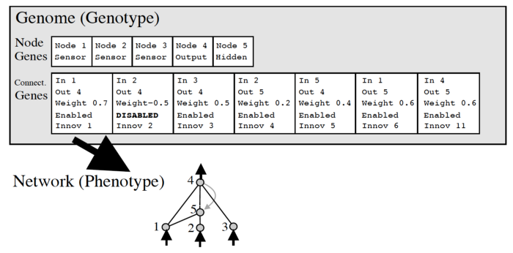

[https://miro.medium.com/max/700/0*Kze4g6cLA3maofxq.png](https://miro.medium.com/max/700/0*Kze4g6cLA3maofxq.png)

**Steps:**

1. Simulation/Selection
2. Crossover/Reproduction
3. Mutation

**Further Analysis:**

1. **Selection**

Select different Parents to propagate,

NEAT emphasizes having less evolved species within the environment to create new effective genes.

pseudo code:

1. **Crossover/Reproduction**

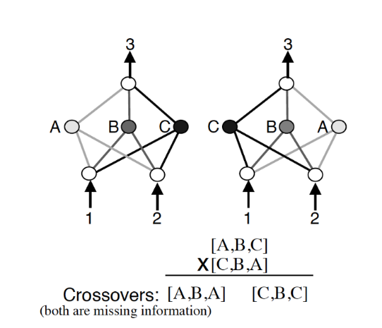

[https://miro.medium.com/max/700/0*AlgDyVgxlUCOlE0B.png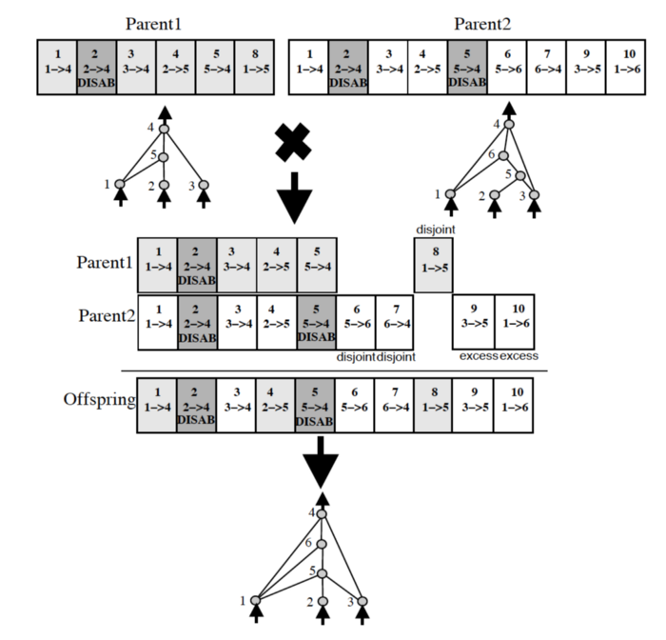](https://miro.medium.com/max/700/0*AlgDyVgxlUCOlE0B.png)

[https://miro.medium.com/max/700/0*N4j_sl8M05G6pXZV.png](https://miro.medium.com/max/700/0*N4j_sl8M05G6pXZV.png)

Crossover takes two parents and “Crosses” them where we use a Dominant/Recessive chance to pass on different genetics to children nodes. So, for example here is some pseudo code:

|  |
| --- |
| If (Gene in both parents):  Pick Random one Between them.  Else:  Child Gets Gene. |

1. **Mutation**

Chance to change a gene.

* Create/Remove NodeGene_t:
  + Create: requires taking existing Edge and splitting in two.
  + Remove: Simply remove Node from list.
* Increase/Decrease weight in Gene:
  + Set Disabled flag to TRUE.

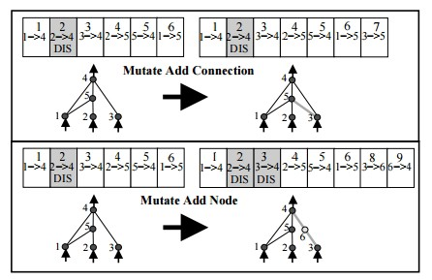

[https://miro.medium.com/max/446/0*hk8JqrWFbRiG04L2.jpg](https://miro.medium.com/max/446/0*hk8JqrWFbRiG04L2.jpg)

Add new node steps:

1. If no edges exist, create one from input to output
2. Select an existing edge, and create node from

**Future Work:**

+Take NEAT and modify it for larger neural networks, so each ‘Node’ is a Block of neurons, each network is trained with back propagation.